**ACKNOWLEDGEMENT**

We are extremely grateful and remain indebted to our guide **Dr. Naveen Tewari** for being a source of inspiration and for his constant support in the Design, Implementation and Evaluation of the project. We are thankful to him for his constant constructive criticism and invaluable suggestions, which benefited us a lot while developing the project on “**ONLINE RESUME BUILDER**”. He has been a constant source of inspiration and motivation for hard work. He has been very co-operative throughout this project work. Through this column, it would be our utmost pleasure to express our warm thanks to him for their encouragement, co-operation and consent without which we mightn’t be able to accomplish this project. Finally, we are very much grateful to the Institute and all the Faculty members, without their personal attention and time to time help and care, it would not have been possible for us to complete this project work. **CERTIFICATE**

This is to certify that the project entitled **Online Resume Builder** System submitted by, Amit Kumar, Roll No. 1461330008, Anjali jalal, Roll No.1461330081, Kusum Pargian, Roll No. 1461330095, Kritika Pant, Roll No.1461330093, Deepak Joshi, Roll No. 1461330013, to the Department of Computer Science Amrapali Institute of Computer Applications has been submitted in partial fulfilment of the requirement of the BCA degree of Kumaon University, Nainital.We confirm that the work contained in the project is our original piece of work and has not been submitted previously for a degree at any university. The analysis and findings are for academic purpose only.

**TO WHOM IT MAY CONCERN**

This is to certify that the students have undergone the project, entitled “ONLINE RESUME BUILDER”, under my supervision. All the students participated actively and completed the project within the time limit. The work carried out by them is satisfactory. I wish them success for their future assignments.

**Dr. Naveen Tewari**

**Project Guide**

**Professor**

**Index**

**Page No**

**I.  Introduction** 3

Project Introduction  
Problem Description

**II. System Study** 4

Existing System with limitationsProposed System with objectives  
Feasibility Studies of project

- Economical  
- Technical  
- Duration

**III. System Analysis** 6

System Flowcharts  
E-R Diagrams  
Data Flow Diagram (DFDs)  
Requirement Specifications

**IV. System Design** 10

File / Database Design  
Input / Output form design  
Screen Design  
Report Design

**V. Coding** 16

List of Programs  
Inputs  
Outputs

**VI. System Testing** 62

Preparation of Test Data & Test Oracle  
Unit Testing, Class Testing  
Testing with dummy / live data

**VII. System Security** 65

Checks and Control   
Encryption, Secure

**VIII. Conclusions** 68

Findings  
Limitations  
Scope for Future Prospects

**I.  Introduction**

**Project Introduction**

Resume is the first meeting between you and a prospective employee more often now than ever. So, how do you want to be remembered? Companies do not have the time to interview every applicant that is interested in the job. If they did, there would not be a company to work for. They use eliminating process. That’s right –resumes.

When a job seeker wants to apply for a job online then generally he/she needs to attach his/her resume with the email.

Online resume building system provides the users the popular resume formats and a better way to show their resumes to the employers. A job seeker does not need to attach a resume with every email. He/she just have to include the URL of his/her resume and the employer can view the resume only by clicking on the link and can download as well.

**Problem Description**

In this present age of competition our resume need to be prepared and updated according to the changing requirements of industry. The present system for resume building just provides Wizard through which one can prepare resume only in given format.

* Inability of modification of data
* Provides fixed format of resume
* Lack of immediate retrieval
* Inability of sharing the resume data
* Lack of expert guidance at every step of building resume

**II. System Study**

**Existing System with limitation**

* Inability of modification of data
* Provides fixed format of resume
* Lack of immediate retrieval
* Inability of sharing the resume data
* Lack of expert guidance at every step of building resume

**Proposed System with objectives**

Our proposed system provides automation to Resume Building. This system provides online storage/ updates and retrieval facility. This system promises very less or no paper work and also provides help to customers and viewers/employers. In this system everything is stored electronically so very less amount of paper work is required and information can be retrieved very easily without searching here and there into registers.

**Feasibility Studies of Project**

The feasibility study is carried out to test whether the proposed system is worth implemented. Feasibility study is the test of proposed system regarding its work ability. The key consideration involved in the feasibility study is

**Technical Feasibility**

Technical Feasibility center on the existing computer system and to what extent it can support the proposed system addition. The technologies and the environment which are used in this project are: Software:

**Behavioral Feasibility**

People are inherently resistant to change and computers have been known to facilitate change. An estimate should be made of how strong a reaction the user staff is likely to have towards the development of computerized system.

**Economic Feasibility**

The procedure is to determine the benefits and savings that are expected from a candidate system and compare it with cost. If a benefit outweighs costs then the decision is made to design and implement the system otherwise further alterations are made in the proposed system.

* + Manpower cost
  + Hardware cost
  + Software cost

**III. System Analysis**

The act, process, or profession of studying an activity (as a procedure, a business, or a physiological function) typically by mathematical means in order to define its goals or purposes and to discover operations and procedures for accomplishing them most efficiently.

**System Flowcharts**

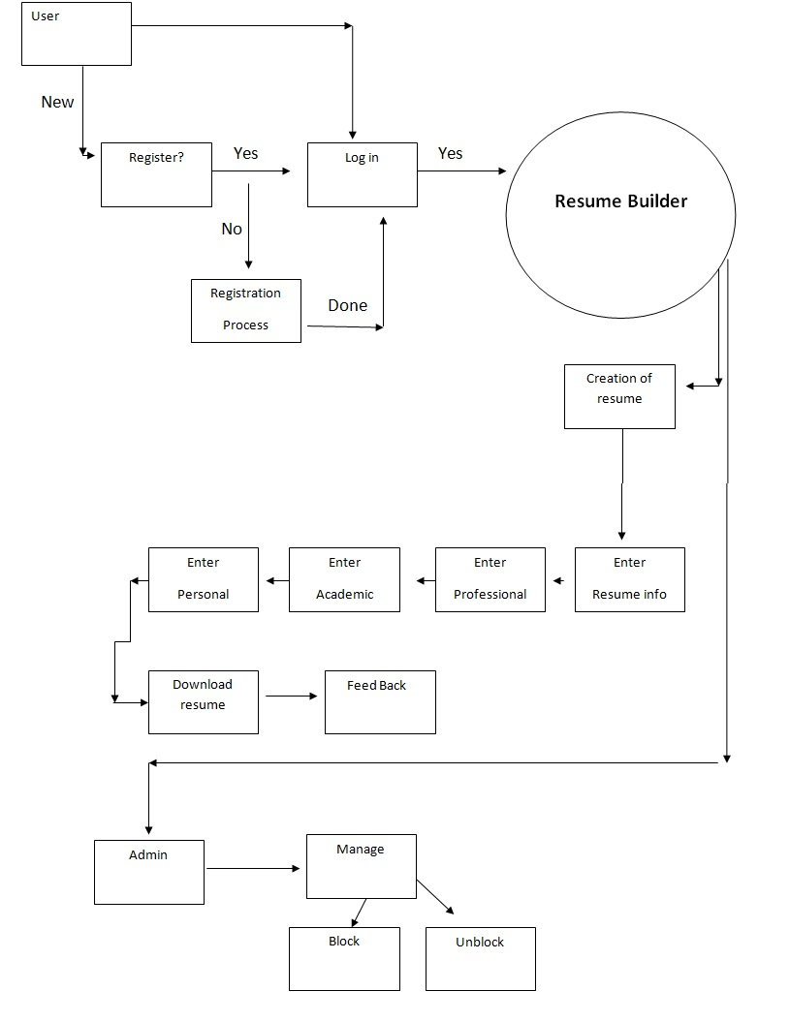

**E-R Diagrams**

Entity Relation Diagram represents the object relationship pairs in graphical forms thus we can say that the primary goal of ER diagrams is represent data objects along with their relationships.ER model for data uses three features to describe data:



**Data flow diagram**

A data flow diagram is graphical representation that depicts the information flow and the transforms that r applied as date moves from input to output. It can be used to represent software at any level of abstraction. In fact DFDs may be partitioned in to levels. That represents increasing information flow and functional details.

DFDs are defined in levels with every level decreasing the level of abstraction as well as defining greater details of the functional organs of the system. A zero level DFD also known as context or fundamental system model represents the entire software elements as a single bubble with input and output data entities which are indicated as incoming and outgoing arrows.



**Requirement Specifications**

**Hardware**

Processor : Pentium / Dual Core / AMD/Core2Duo

Ram : 1GB

Color monitor

Keyboard

Mouse

Printer etc.

**Software**

Operating System : Windows7

## Browser Requirements

* IE: Version 9+
* Chrome: Version 32+
* Firefox: Version 3.5+
* Safari: Version 4.0+

**Tablet & Mobile OS**

* I OS Safari: Version 3.2+
* Android Browser: Version 2.1+
* Chrome for Android: 35+
* Firefox for Android: 29+
* IE mobile 10+

**IV. System Design**

Systems design is the process of defining the architecture, components, modules, interfaces, and data for a system to satisfy specified requirements. Systems design could be seen as the application of systems theory to product development.

**Database Design**

Database design is the process of producing a detailed data model of database. This data model contains all the needed logical and physical design choices and physical storage parameters needed to generate a design in a data definition language, which can then be used to create a database

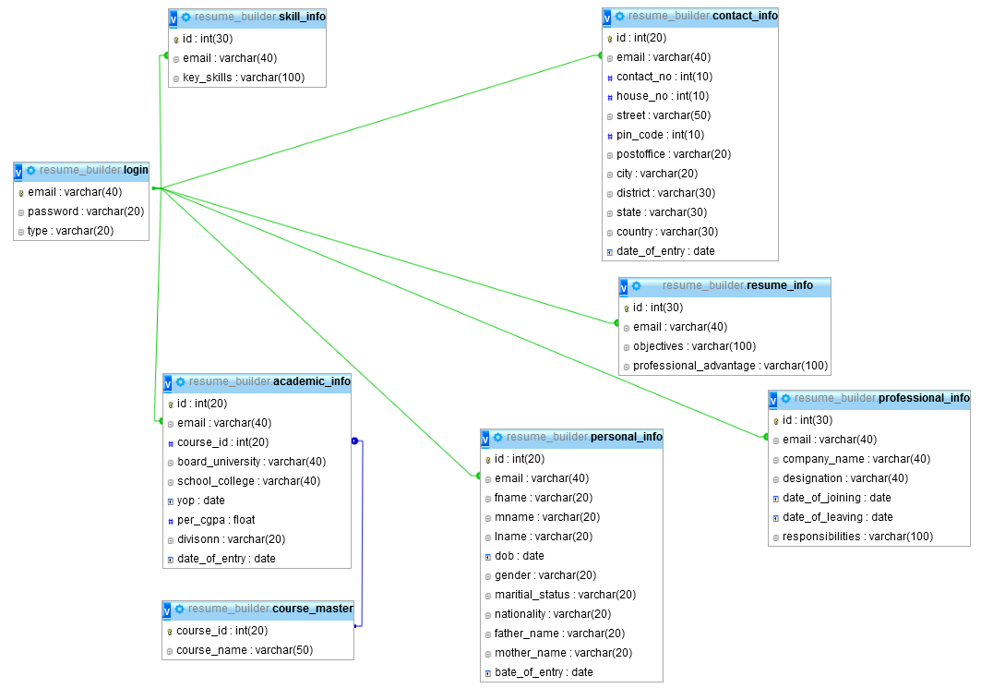

**Input/output Form Design**

**Input Design**

Inaccurate input data are the most common causes of errors in data processing. Errors entered by data entry operators can be controlled by the Input design. "Input design is the process of converting user originated inputs to system based formats". It consists of developing specification and procedure for data preparation. And it is assure by the using of bootstrap technology.

**Output Design**

The term output necessarily implies to information on printed or displayed by an information system. Following are the activities that are carried out in output design stage.

Ø  Identification of specific output required to meet the information requirements.

Ø  Selecting of methods for processing outputs.

Ø  Designing of reports, formats or other documents that acts as a carrier of information.

**Form Design**

Form is a formatted document containing blank fields that users can fill in with data. The data that the form carry comes from people and the informational output of the system goes to people. It is a basic business tool (whether printed or electronic) for collecting and transmitting information. And it is assured by the using of technology bootstrap.

**Screen Design**

User interface is the front-end application view to which user interacts in order to use the software. User can manipulate and control the software as well as hardware by means of user interface. Today, user interface is found at almost every place where digital technology exists, right from computers, mobile phones, cars, music players, airplanes, ships etc.

User interface is part of software and is designed such a way that it is expected to provide the user insight of the software. UI provides fundamental platform for human-computer interaction.

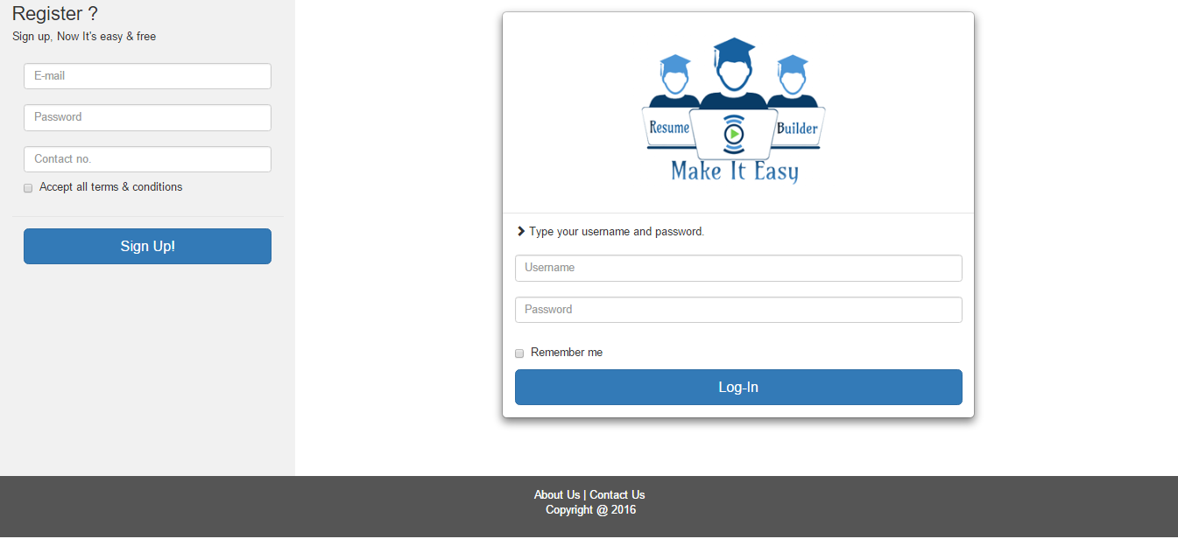

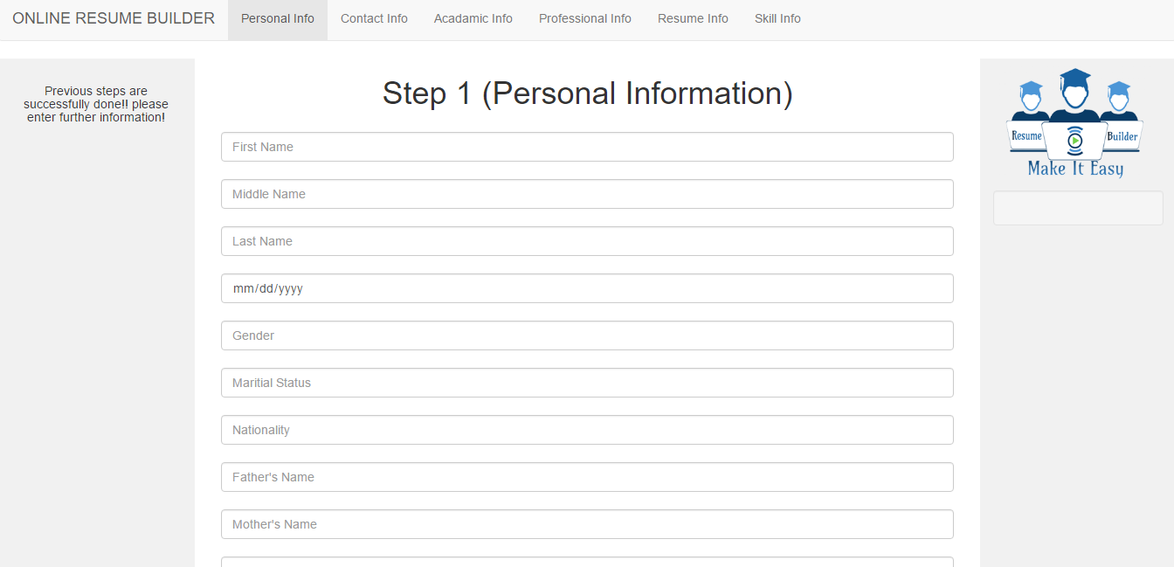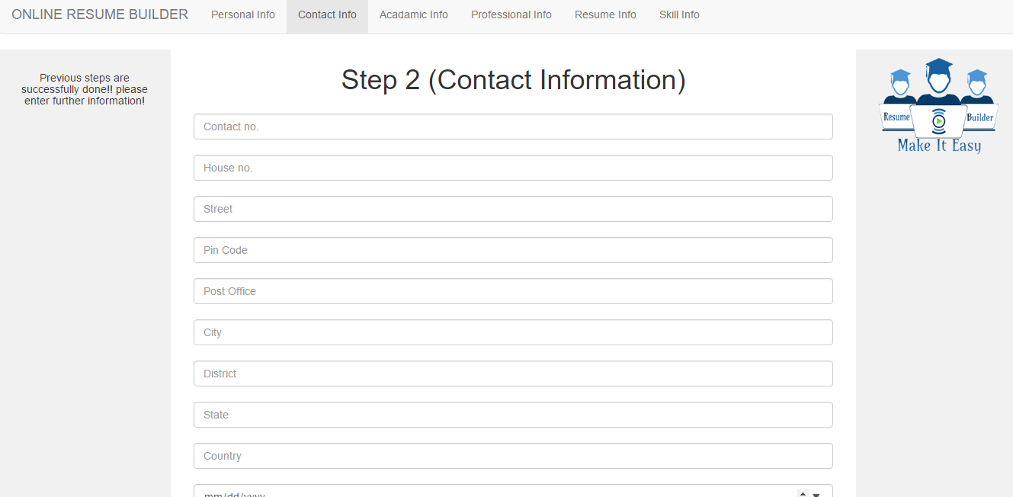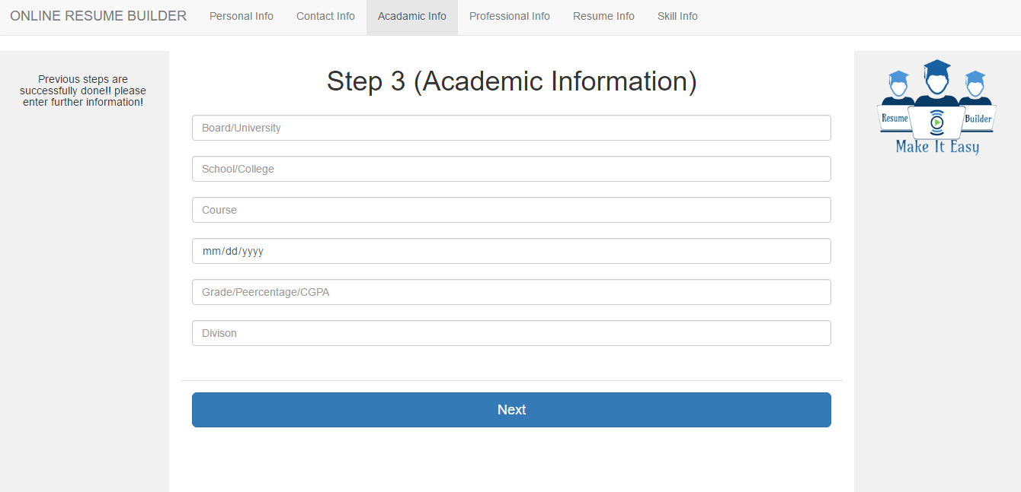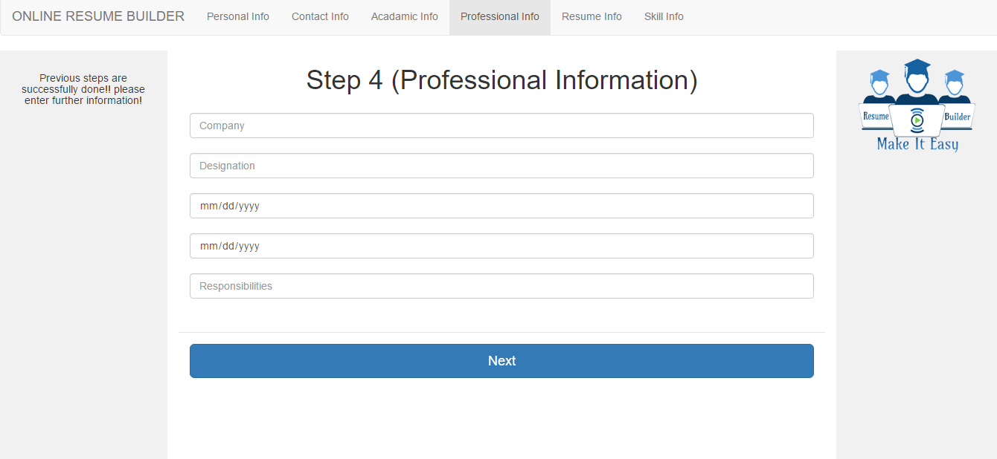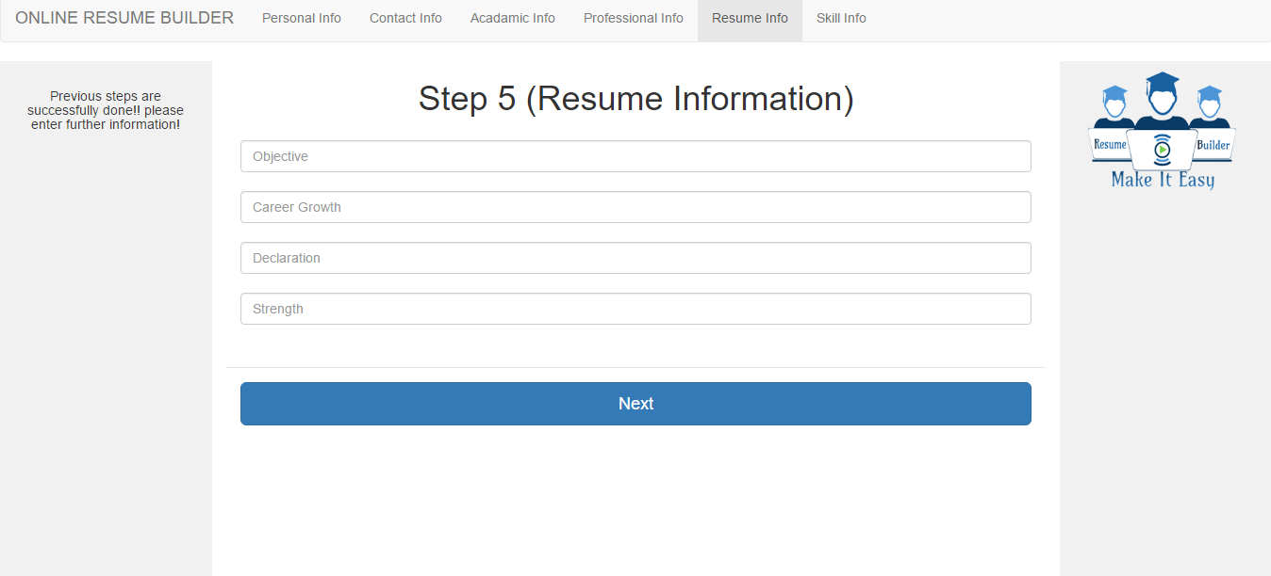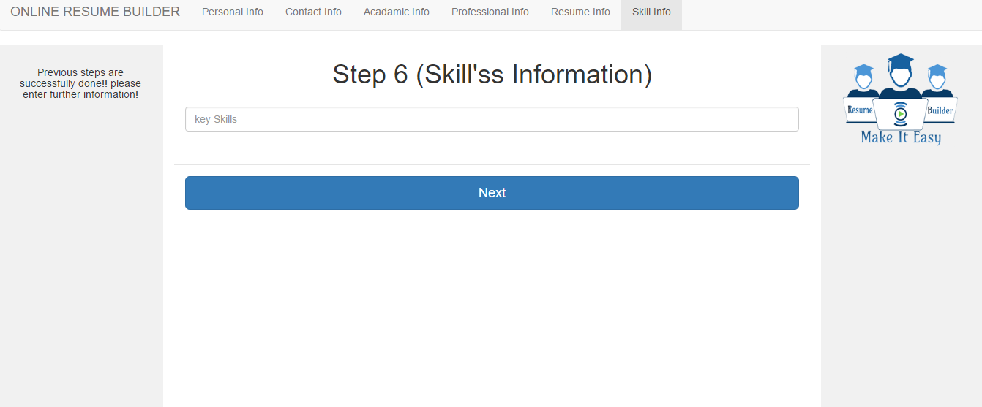

**Report**

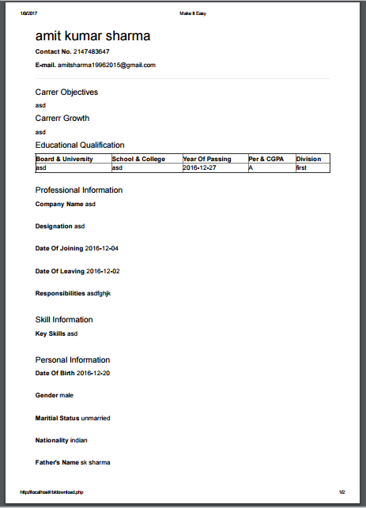

**V. Coding**

**List of Programs**

* Login Module
* Registration Module
* Personal Info. Module
* Academic Info Module
* Skill Info
* Contact Info
* Resume Info
* Professional Info
* Logout Module
* Download Module

**Index Page**

<?php include('header.php');?>

<body>

<div class="container-fluid">

<div class="row content1">

<div class="col-sm-3 sidenav">

<h3>Register ?</h3>

<h5>Sign up, Now It's easy & free</h5 >

<form id="login-form" method="post" action="insert.php">

<div class="modal-body">

<input id="login_username" class="form-control" name="email" type="text" placeholder="E-mail" required><br>

<input id="login_password" class="form-control" name="password" type="password" placeholder="Password" required><br>

<input id="login_password" class="form-control" name="contact" type="text" placeholder="Contact no." required>

<div class="checkbox">

<label>

<input type="checkbox"> Accept all terms & conditions

</label>

</div>

</div>

<div class="modal-footer">

<div>

<button type="submit" class="btn btn-primary btn-lg btn-block">Sign Up!</button>

</div>

</div>

</form>

</div>

<div class="col-sm-9">

<div class="container-fluid">

<!-- BEGIN # BOOTSNIP INFO -->

<!-- END # BOOTSNIP INFO -->

<!-- BEGIN # MODAL LOGIN -->

<div class="modal-dialog">

<div class="modal-content">

<div class="modal-header" align="center">

<img class="img-responsive id="img_logo" " src="images/main_logo.png">

<button type="button" class="close" data-dismiss="modal" aria-label="Close">

</button>

</div>

<!-- Begin # DIV Form -->

<div id="div-forms">

<!-- Begin # Login Form -->

<form id="login-form" method="POST" action="connectivity.php">

<div class="modal-body">

<div id="div-login-msg">

<div id="icon-login-msg" class="glyphicon glyphicon-chevron-right"></div>

<span id="text-login-msg">Type your username and password.</span>

</div><br>

<input type="text" id="login_username" class="form-control" name="user" placeholder="Username"><br>

<input type="password" id="login_password" class="form-control" name="pass" placeholder="Password"><br>

<div class="checkbox">

<label>

<input type="checkbox"> Remember me

</label>

</div>

<input id="button" class="btn btn-primary btn-lg btn-block" type="submit" name="submit" value="Log-In">

</div>

</form>

<!-- End # Login Form -->

<!-- Begin | Lost Password Form -->

<form id="lost-form" style="display:none;">

<div class="modal-body">

<div id="div-lost-msg">

<div id="icon-lost-msg" class="glyphicon glyphicon-chevron-right"></div>

<span id="text-lost-msg">Type your e-mail.</span>

</div>

<input id="lost_email" class="form-control" type="text" placeholder="E-Mail (type ERROR for error effect)" required>

</div>

<div class="modal-footer">

<div>

<button type="submit" class="btn btn-primary btn-lg btn-block">Send</button>

</div>

<div>

<button id="lost_login_btn" type="button" class="btn btn-link">Log In</button>

<button id="lost_register_btn" type="button" class="btn btn-link">Register</button>

</div>

</div>

</form>

<!-- End | Lost Password Form -->

</div>

<!-- End # DIV Form -->

</div>

</div>

</div>

</div>

<!-- END # MODAL LOGIN -->

<div class="clearing"></div>

<footer class="footer">

<p align="center">About Us | Contact Us <br> Copyright @ 2016</p>

</footer>

</body>

</html>

**Header Page (header.php)**

<!DOCTYPE html>

<html lang="en">

<head>

<title>Make It Easy</title>

<link rel="icon" href="images/main_logo.ico">

<meta charset="utf-8">

<meta name="viewport" content="width=device-width, initial-scale=1">

<link rel="stylesheet" href="css/bootstrap.min.css">

<script src="jquery/1.12.4/jquery.min.js"></script>

<script src="js/bootstrap.min.js"></script>

<style>

/* Set height of the grid so .sidenav can be 100% (adjust if needed) */

.row.content {height: 650px}

.row.content1 {height: 620px}

.clearing{

clear:both;

}

/* Set gray background color and 100% height */

.sidenav {

background-color: #f1f1f1;

height: 100%;

}

/* Set black background color, white text and some padding */

footer {

background-color: #555;

color: white;

padding: 15px;

width:100%;

height=16.6%;

}

/* On small screens, set height to 'auto' for sidenav and grid */

@media screen and (max-width: 767px) {

.sidenav {

height: auto;

padding: 15px;

}

.row.content {height: auto;}

}

</style>

<script type="text/javascript>">

</script>

</head>

**Connectivity Page (connect.php)**

<?php

$host='127.0.0.1';

$user='root';

$pass='';

$db='resume_builder';

$conn=mysql_connect($host,$user,$pass);

if($conn)

{

if(mysql_selectdb($db,$conn))

echo ' ';

}

else

{

echo 'error';

}

?>

**Login Page (connectivity.php)**

<?php session_start();

define('DB_HOST', 'localhost');

define('DB_NAME', 'resume_builder');

define('DB_USER','root');

define('DB_PASSWORD','');

$con=mysql_connect(DB_HOST,DB_USER,DB_PASSWORD) or die("Failed to connect to MySQL: " . mysql_error());

$db=mysql_select_db(DB_NAME,$con) or die("Failed to connect to MySQL: " . mysql_error()); $ID = $_POST['user']; $Password = $_POST['pass'];

if(isset($_POST['submit']))

{

if(!empty($_POST['user']))

{

//echo $_POST['pass'];

//echo "SELECT * FROM login where email = '".$_POST['user']."' AND password = '".$_POST['pass']."'";

$query = mysql_query("SELECT * FROM login where email = '".$_POST['user']."' AND password = '".$_POST['pass']."'");

$row = mysql_fetch_array($query);

if($row['email']!="")

{

$_SESSION['email'] = $row['email'];

header('location:personal.php');

echo "SUCCESSFULLY LOGIN TO USER PROFILE PAGE.. .";

}else{

header('location:index.php');

echo "SORRY... YOU ENTERD WRONG ID AND PASSWORD... PLEASE RETRY...";

}

}else{

header('location:index.php');

}

}

else{header('location:index.php');}?>

**Personal Module page (personal.php)**

<?php session_start();

if(isset($_SESSION['email'])){

include('header.php');

include('connect.php');

$email=$_SESSION['email'];

$sql=mysql_query("call GetAll('$email')") or die(mysql_error());

$result=mysql_fetch_assoc($sql);

?>

<body>

<nav class="navbar navbar-default">

<div class="container-fluid">

<div class="navbar-header">

<button type="button" class="navbar-toggle" data-toggle="collapse" data-target="#myNavbar">

<span class="icon-bar"></span>

<span class="icon-bar"></span>

<span class="icon-bar"></span>

<span class="icon-bar"></span>

<span class="icon-bar"></span>

<span class="icon-bar"></span>

</button>

<a class="navbar-brand" href="#">ONLINE RESUME BUILDER</a>

</div>

<div class="collapse navbar-collapse" id="myNavbar">

<ul class="nav navbar-nav">

<li class="active"><a href="personal.php">Personal Info</a></li>

<li><a href="contact.php">Contact Info</a></li>

<li><a href="academic.php">Acadamic Info</a></li>

<li><a href="professional.php">Professional Info</a></li>

<li><a href="master.php">Resume Info</a></li>

<li><a href="skills.php">Skill Info</a></li>

</ul>

<ul class="nav navbar-nav navbar-right">

</ul>

</div>

</div>

</nav>

<div class="container-fluid text-center">

<div class="row content">

<div class="col-sm-2 sidenav"><br>

<p><h5>Previous steps are successfully done!! please enter further information!</h5></p>

</div>

<div class="col-sm-8 text-left">

<h1 align="center"> Step 1 (Personal Information)</h1>

<form id="login-form" method="POST" action="insert_personal.php">

<div class="modal-body">

<input id="login_username" class="form-control" type="text" placeholder="First Name" required name="personal"><br>

<input id="login_password" class="form-control" type="text" placeholder="Middle Name" required name="personal2"><br>

<input id="login_password" class="form-control" type="text" placeholder="Last Name" required name="personal3"><br>

<input id="login_username" class="form-control" type="Date" placeholder="Date Of Birth" required name="personal4"><br>

<input id="login_password" class="form-control" type="text" placeholder="Gender" required name="personal5"><br>

<input id="login_password" class="form-control" type="text" placeholder="Maritial Status" required name="personal6"><br>

<input id="login_username" class="form-control" type="text" placeholder="Nationality" required name="personal7"><br>

<input id="login_password" class="form-control" type="text" placeholder="Father's Name" required name="personal8"><br>

<input id="login_username" class="form-control" type="text" placeholder="Mother's Name" required name="personal9"><br>

<input id="login_password" class="form-control" type="Date" placeholder="Date Of Entry" required name="personal10"><br>

<div class="checkbox">

<label>

<input type="checkbox"> Accept all terms & conditions

</label>

</div>

</div>

<div class="modal-footer">

<div>

<button type="submit" class="btn btn-primary btn-lg btn-block">Next</button>

</div>

</div>

</form>

</div>

<div class="col-sm-2 sidenav">

<div class=>

<img class="img-responsive id="img_logo" " src="images/main_logo.png">

</div>

<div class="well">

</div>

</div>

</div>

</div>

<footer class="footer">

<p align="center">About Us | Contact Us <br> Copyright @ 2016</p>

</footer>

</body>

</html>

<?php

} else {

header("Location: index.php");

}

?>

**Personal Insert Page (personal_insert.php)**

<?php include('connect.php');

session_start();

$personal = $_POST['personal'];

$personal2 = $_POST['personal2'];

$personal3 = $_POST['personal3'];

$personal4 = $_POST['personal4'];

$personal5 = $_POST['personal5'];

$personal6 = $_POST['personal6'];

$personal7 = $_POST['personal7'];

$personal8 = $_POST['personal8'];

$personal9 = $_POST['personal9'];

$personal10 = $_POST['personal10'];

$email=$_SESSION['email'];

$sql = "INSERT INTO personal_info(fname,email, mname, lname, dob, gender, maritial_status, nationality, father_name, mother_name, bate_of_entry )

VALUES ('$personal','$email', '$personal2', '$personal3', '$personal4', '$personal5', '$personal6', '$personal7', '$personal8', '$personal9', '$personal10')";

$sql=mysql_query($sql) or die(mysql_error());

echo "New record created successfully";

header('location:contact.php');

mysql_close($conn);

?>

**Academic Information module page (academic.php)**

<?php session_start();

if(isset($_SESSION['email'])){

include('header.php');

include('connect.php');

$email=$_SESSION['email'];

$sql=mysql_query("call GetAll('$email')") or die(mysql_error());

$result=mysql_fetch_assoc($sql);

?>

<body>

<nav class="navbar navbar-default">

<div class="container-fluid">

<div class="navbar-header">

<button type="button" class="navbar-toggle" data-toggle="collapse" data-target="#myNavbar">

<span class="icon-bar"></span>

<span class="icon-bar"></span>

<span class="icon-bar"></span>

<span class="icon-bar"></span>

<span class="icon-bar"></span>

<span class="icon-bar"></span>

</button>

<a class="navbar-brand" href="#">ONLINE RESUME BUILDER</a>

</div>

<div class="collapse navbar-collapse" id="myNavbar">

<ul class="nav navbar-nav">

<li><a href="personal.php">Personal Info</a></li>

<li><a href="contact.php">Contact Info</a></li>

<li class="active"><a href="academic.php">Acadamic Info</a></li>

<li><a href="professional.php">Professional Info</a></li>

<li><a href="master.php">Resume Info</a></li>

<li><a href="skills.php">Skill Info</a></li>

</ul>

<ul class="nav navbar-nav navbar-right">

</ul>

</div>

</div>

</nav>

<div class="container-fluid text-center">

<div class="row content">

<div class="col-sm-2 sidenav"><br>

<p><h5>Previous steps are successfully done!! please enter further information!</h5></p>

</div>

<div class="col-sm-8 text-center">

<h1> Step 3 (Academic Information)</h1>

<form id="login-form" method="post" action="academic_insert.php">

<div class="modal-body">

<input id="login_username" class="form-control" type="text" placeholder="Board/University" required name="a1"><br>

<input id="login_username" class="form-control" type="text" placeholder="School/College" required name="a2"><br>

<input id="login_username" class="form-control" type="text" placeholder="Course" required name="a3"><br>

<input id="login_username" class="form-control" type="Date" placeholder="Passing Year" required name="a4"><br>

<input id="login_username" class="form-control" type="text" placeholder="Grade/Peercentage/CGPA" required name="a5"><br>

<input id="login_username" class="form-control" type="text" placeholder="Divison" required name="a6"><br>

<div class="checkbox">

</div>

</div>

<div class="modal-footer">

<div>

<button type="submit" class="btn btn-primary btn-lg btn-block">Next</button>

</div>

</div>

</form>

</div>

<div class="col-sm-2 sidenav">

<div class=>

<img class="img-responsive id="img_logo" " src="images/main_logo.png">

</div>

</div>

</div>

</div>

<footer class="footer">

<p align="center">About Us | Contact Us <br> Copyright @ 2016</p>

</footer>

</body>

</html>

<?php

} else {

header("Location: index.php");

}

?>

**Academic data insert page(academic_insert.php)**

<?php include('connect.php');

session_start();

$a1 = $_POST['a1'];

$a2 = $_POST['a2'];

$a3 = $_POST['a3'];

$a4 = $_POST['a4'];

$a5 = $_POST['a5'];

$a6 = $_POST['a6'];

$email=$_SESSION['email'];

$sql = "INSERT INTO academic(email, board_university, school_college, course, yop, per_cgpa, divison)

VALUES ('$email', '$a1', '$a2', '$a3', '$a4', '$a5', '$a6')";

$sql=mysql_query($sql) or die(mysql_error());

echo "New record created successfully";

header('location:professional.php');

mysql_close($conn);

?>

**Skill Information module page (skills.php)**

<?php session_start();

if(isset($_SESSION['email'])){

include('header.php');

include('connect.php');

$email=$_SESSION['email'];

$sql=mysql_query("call GetAll('$email')") or die(mysql_error());

$result=mysql_fetch_assoc($sql);

?>

<body>

<nav class="navbar navbar-default">

<div class="container-fluid">

<div class="navbar-header">

<button type="button" class="navbar-toggle" data-toggle="collapse" data-target="#myNavbar">

<span class="icon-bar"></span>

<span class="icon-bar"></span>

<span class="icon-bar"></span>

<span class="icon-bar"></span>

<span class="icon-bar"></span>

<span class="icon-bar"></span>

</button>

<a class="navbar-brand" href="#">ONLINE RESUME BUILDER</a>

</div>

<div class="collapse navbar-collapse" id="myNavbar">

<ul class="nav navbar-nav">

<li><a href="personal.php">Personal Info</a></li>

<li><a href="contact.php">Contact Info</a></li>

<li ><a href="academic.php">Acadamic Info</a></li>

<li><a href="professional.php">Professional Info</a></li>

<li><a href="master.php">Resume Info</a></li>

<li class="active"><a href="skills.php">Skill Info</a></li>

</ul>

<ul class="nav navbar-nav navbar-right">

</ul>

</div>

</div>

</nav>

<div class="container-fluid text-center">

<div class="row content">

<div class="col-sm-2 sidenav"><br>

<p><h5>Previous steps are successfully done!! please enter further information!</h5></p>

</div>

<div class="col-sm-8 text-center">

<h1> Step 6 (Skill's Information)</h1>

<form id="login-form" method="post" action="skills_insert.php">

<div class="modal-body">

<input id="login_username" class="form-control" type="text" placeholder="key Skills" name="s1" required><br>

<div class="checkbox">

</div>

</div>

<div class="modal-footer">

<div>

<button type="submit" class="btn btn-primary btn-lg btn-block">Next</button>

</div>

</div>

</form>

</div>

<div class="col-sm-2 sidenav">

<div class=>

<img class="img-responsive id="img_logo" " src="images/main_logo.png">

</div>

</div>

</div>

</div>

<footer class="footer">

<p align="center">About Us | Contact Us <br> Copyright @ 2016</p>

</footer>

</body>

</html>

<?php

} else {

header("Location: index.php");

}

?>

**Skill Information module data insert page (skills_insert.php)**

<?php include('connect.php');

session_start();

$s1 = $_POST['s1'];

$email=$_SESSION['email'];

$sql = "INSERT INTO skill_info(email, key_skills)

VALUES ('$email','$s1')";

$sql=mysql_query($sql) or die(mysql_error());

echo "New record created successfully";

header('location:download.php');

mysql_close($conn);

?>

**Contact Information page (contact.php)**

<?php session_start();

if(isset($_SESSION['email'])){

include('header.php');

include('connect.php');

$email=$_SESSION['email'];

$sql=mysql_query("call GetAll('$email')") or die(mysql_error());

$result=mysql_fetch_assoc($sql);

?>

<body>

<nav class="navbar navbar-default">

<div class="container-fluid">

<div class="navbar-header">

<button type="button" class="navbar-toggle" data-toggle="collapse" data-target="#myNavbar">

<span class="icon-bar"></span>

<span class="icon-bar"></span>

<span class="icon-bar"></span>

<span class="icon-bar"></span>

<span class="icon-bar"></span>

<span class="icon-bar"></span>

</button>

<a class="navbar-brand" href="#" class="logo">ONLINE RESUME BUILDER</a>

</div>

<div class="collapse navbar-collapse" id="myNavbar">

<ul class="nav navbar-nav">

<li><a href="personal.php">Personal Info</a></li>

<li class="active"><a href="contact.php">Contact Info</a></li>

<li ><a href="academic.php">Acadamic Info</a></li>

<li><a href="professional.php">Professional Info</a></li>

<li><a href="master.php">Resume Info</a></li>

<li><a href="skills.php">Skill Info</a></li>

</ul>

<ul class="nav navbar-nav navbar-right">

</ul>

</div>

</div>

</nav>

<div class="container-fluid text-center">

<div class="row content">

<div class="col-sm-2 sidenav"><br>

<p><h5>Previous steps are successfully done!! please enter further information!</h5></p>

</div>

<div class="col-sm-8 text-center">

<h1> Step 2 (Contact Information)</h1>

<form id="login-form" method="post" action="contact_insert.php">

<div class="modal-body">

<input id="login_username" class="form-control" type="number_format" placeholder="Contact no." required name="c1"><br>

<input id="login_username" class="form-control" type="text" placeholder="House no." required name="c2"><br>

<input id="login_username" class="form-control" type="text" placeholder="Street" required name="c3"><br>

<input id="login_username" class="form-control" type="number_format" placeholder="Pin Code" required name="c4"><br>

<input id="login_username" class="form-control" type="text" placeholder="Post Office" required name="c5"><br>

<input id="login_username" class="form-control" type="text" placeholder="City" required name="c6"><br>

<input id="login_username" class="form-control" type="text" placeholder="District" required name="c7"><br>

<input id="login_username" class="form-control" type="text" placeholder="State" required name="c8"><br>

<input id="login_username" class="form-control" type="text" placeholder="Country" required name="c9"><br>

<input id="login_username" class="form-control" type="Date" placeholder="Date Of Entry" required name="c10"><br>

<div class="checkbox">

</div>

</div>

<div class="modal-footer">

<div>

<button type="submit" class="btn btn-primary btn-lg btn-block">Next</button>

</div>

</div>

</form>

</div>

<div class="col-sm-2 sidenav">

<div class=>

<img class="img-responsive id="img_logo" " src="images/main_logo.png">

</div>

</div>

</div>

</div>

<footer class="footer">

<p align="center">About Us | Contact Us <br> Copyright @ 2016</p>

</footer>

</body>

</html>

<?php

} else {

header("Location: index.php");

}

?>

**Contact Info data insert page (contact_insert.php)**

<?php include('connect.php');

session_start();

$c1 = $_POST['c1'];

$c2 = $_POST['c2'];

$c3 = $_POST['c3'];

$c4 = $_POST['c4'];

$c5 = $_POST['c5'];

$c6 = $_POST['c6'];

$c7 = $_POST['c7'];

$c8 = $_POST['c8'];

$c9 = $_POST['c9'];

$c10 = $_POST['c10'];

$email=$_SESSION['email'];

$sql = "INSERT INTO contact_info(email, contact_no, house_no, street, pin_code, postoffice, city, district, state, country, date_of_entry)

VALUES ('$email','$c1', '$c2', '$c3', '$c4', '$c5', '$c6', '$c7', '$c8', '$c9', '$c10')";

$sql=mysql_query($sql) or die(mysql_error());

echo "New record created successfully";

header('location:academic.php');

mysql_close($conn);

?>

**Resume Information page (master.php)**

<?php session_start();

if(isset($_SESSION['email'])){

include('header.php');

include('connect.php');

$email=$_SESSION['email'];

$sql=mysql_query("call GetAll('$email')") or die(mysql_error());

$result=mysql_fetch_assoc($sql);

?>

<body>

<nav class="navbar navbar-default">

<div class="container-fluid">

<div class="navbar-header">

<button type="button" class="navbar-toggle" data-toggle="collapse" data-target="#myNavbar">

<span class="icon-bar"></span>

<span class="icon-bar"></span>

<span class="icon-bar"></span>

<span class="icon-bar"></span>

<span class="icon-bar"></span>

<span class="icon-bar"></span>

</button>

<a class="navbar-brand" href="#">ONLINE RESUME BUILDER</a>

</div>

<div class="collapse navbar-collapse" id="myNavbar">

<ul class="nav navbar-nav">

<li><a href="personal.php">Personal Info</a></li>

<li><a href="contact.php">Contact Info</a></li>

<li ><a href="academic.php">Acadamic Info</a></li>

<li><a href="professional.php">Professional Info</a></li>

<li class="active"><a href="master.php">Resume Info</a></li>

<li><a href="skills.php">Skill Info</a></li>

</ul>

<ul class="nav navbar-nav navbar-right">

</ul>

</div>

</div>

</nav>

<div class="container-fluid text-center">

<div class="row content">

<div class="col-sm-2 sidenav"><br>

<p><h5>Previous steps are successfully done!! please enter further information!</h5></p>

</div>

<div class="col-sm-8 text-center">

<h1> Step 5 (Resume Information)</h1>

<form id="login-form" method="post" action="master_insert.php">

<div class="modal-body">

<input id="login_username" class="form-control" type="text" placeholder="Objective" name="m1" required><br>

<input id="login_username" class="form-control" type="text" placeholder="Career Growth" name="m2" required><br>

<input id="login_username" class="form-control" type="text" placeholder="Declaration" name="m3" required><br>

<input id="login_username" class="form-control" type="text" placeholder="Strength" name="m4" required><br>

<div class="checkbox">

</div>

</div>

<div class="modal-footer">

<div>

<button type="submit" class="btn btn-primary btn-lg btn-block">Next</button>

</div>

</div>

</form>

</div>

<div class="col-sm-2 sidenav">

<div class=>

<img class="img-responsive id="img_logo" " src="images/main_logo.png">

</div>

</div>

</div>

</div>

<footer class="footer">

<p align="center">About Us | Contact Us <br> Copyright @ 2016</p>

</footer>

</body>

</html>

<?php

} else {

header("Location: index.php");

}

?>

**Master Page Data Insert (master_insert)**

<?php include('connect.php');

session_start();

$m1 = $_POST['m1'];

$m2 = $_POST['m2'];

$m3 = $_POST['m3'];

$m4 = $_POST['m4'];

$email=$_SESSION['email'];

$sql = "INSERT INTO resume_info(email, objectives, career_growth, declearation, strength)

VALUES ('$email','$m1', '$m2', '$m3', '$m4')";

$sql=mysql_query($sql) or die(mysql_error());

echo "New record created successfully";

header('location:skills.php');

mysql_close($conn);

?>

**Professional Information Module page (professional.php)**

<?php session_start();

if(isset($_SESSION['email'])){

include('header.php');

include('connect.php');

$email=$_SESSION['email'];

?>

<body>

<nav class="navbar navbar-default">

<div class="container-fluid">

<div class="navbar-header">

<button type="button" class="navbar-toggle" data-toggle="collapse" data-target="#myNavbar">

<span class="icon-bar"></span>

<span class="icon-bar"></span>

<span class="icon-bar"></span>

<span class="icon-bar"></span>

<span class="icon-bar"></span>

<span class="icon-bar"></span>

</button>

<a class="navbar-brand" href="#">ONLINE RESUME BUILDER</a>

</div>

<div class="collapse navbar-collapse" id="myNavbar">

<ul class="nav navbar-nav">

<li><a href="personal.php">Personal Info</a></li>

<li><a href="contact.php">Contact Info</a></li>

<li ><a href="academic.php">Acadamic Info</a></li>

<li class="active"><a href="professional.php">Professional Info</a></li>

<li><a href="master.php">Resume Info</a></li>

<li><a href="skills.php">Skill Info</a></li>

</ul>

<ul class="nav navbar-nav navbar-right">

</ul>

</div>

</div>

</nav>

<div class="container-fluid text-center">

<div class="row content">

<div class="col-sm-2 sidenav"><br>

<p><h5>Previous steps are successfully done!! please enter further information!</h5></p>

</div>

<div class="col-sm-8 text-center">

<h1> Step 4 (Professional Information)</h1>

<form id="login-form" method="post" action="professional_insert.php">

<div class="modal-body">

<input id="login_username" class="form-control" type="text" placeholder="Company" name="p1" required><br>

<input id="login_username" class="form-control" type="text" placeholder="Designation" name="p2" required><br>

<input id="login_username" class="form-control" type="date" placeholder="Date Of Joining" name="p3" required><br>

<input id="login_username" class="form-control" type="date" placeholder="Date Of Leaving" name="p4" required><br>

<input id="login_username" class="form-control" type="text" placeholder="Responsibilities" name="p5" required><br>

<div class="checkbox">

</div>

</div>

<div class="modal-footer">

<div>

<button type="submit" class="btn btn-primary btn-lg btn-block">Next</button>

</div>

</div>

</form>

</div>

<div class="col-sm-2 sidenav">

<div class=>

<img class="img-responsive id="img_logo" " src="images/main_logo.png">

</div>

</div>

</div>

</div>

<footer class="footer">

<p align="center">About Us | Contact Us <br> Copyright @ 2016</p>

</footer>>

</body>

</html>

<?php

} else {

header("Location: index.php");

}

?>

**Professional Insert Page (professional_insert.php)**

<?php include('connect.php');

session_start();

$p1 = $_POST['p1'];

$p2 = $_POST['p2'];

$p3 = $_POST['p3'];

$p4 = $_POST['p4'];

$p5 = $_POST['p5'];

$email=$_SESSION['email'];

$sql = "INSERT INTO professional_info(email, company_name, designation, date_of_joining, date_of_leaving, responsibilities)

VALUES ('$email','$p1', '$p2', '$p3', '$p4', '$p5')";

$sql=mysql_query($sql) or die(mysql_error());

echo "New record created successfully";

header('location:master.php');

mysql_close($conn);

?>

**Logout Module page (logout.php)**

<?php session_start();

session_unset();

session_destroy();

header('location:index.php');

?>

**Download page (download.php)**

<?php session_start();

if(isset($_SESSION['email'])){

include('header.php');

include('connect.php');

$email=$_SESSION['email'];

$sql=mysql_query("call GetAll('$email')") or die(mysql_error());

$result=mysql_fetch_assoc($sql);

?>

<div class="col-sm-9">

<div class="container-fluid">

<h2><?php echo $result['fname']." ".$result['mname']." ".$result['lname'];?></h2>

<p><b>Contact No. </b><?php echo $result['contact_no'];?></p>

<p><b>E-mail. </b><?php echo $result['email'];?></p>

<hr>

<p><h4>Carrer Objectives</h4>

<?php echo $result['objectives'];?></p>

<p><h4>Carrerr Growth </h4>

<?php echo $result['career_growth'];?></p>

<p><h4>Educational Qualification </h4>

<div style="overflow-x:auto;">

<table border="1px;" width="100%">

<tr>

<th> Board & University </th>

<th>School & College</th>

<th>Year Of Passing</th>

<th>Per & CGPA</th>

<th>Division</th>

</tr>

<tr>

<td><?php echo $result['board_university']?></td>

<td><?php echo $result['school_college']?></td>

<td><?php echo $result['yop']?></td>

<td><?php echo $result['per_cgpa']?></td>

<td><?php echo $result['divison']?></td>

</tr>

</table>

</div><br>

<p><h4>Professional Information </h4></P>

<p><b>Company Name </b><?php echo $result['company_name'];?></p><br>

<p><b>Designation </b><?php echo $result['designation'];?></p><br>

<p><b>Date Of Joining </b><?php echo $result['date_of_joining'];?></p><br>

<p><b>Date Of Leaving </b><?php echo $result['date_of_leaving'];?></p><br>

<p><b>Responsibilities </b><?php echo $result['responsibilities'];?></p><br>

<p><h4>Skill Information </h4></P>

<p><b>Key Skills </b><?php echo $result['key_skills'];?></p><br>

<p><h4>Personal Information </h4></P>

<p><b>Date Of Birth </b><?php echo $result['dob'];?></p><br>

<p><b>Gender </b><?php echo $result['gender'];?></p><br>

<p><b>Maritial Status </b><?php echo $result['maritial_status'];?></p><br>

<p><b>Nationality </b><?php echo $result['nationality'];?></p><br>

<p><b>Father's Name </b><?php echo $result['father_name'];?></p><br>

<p><b>Mother's Name </b><?php echo $result['mother_name'];?></p><br>

<p><h4>Contact Information </h4></P>

<p><b>House No. </b><?php echo $result['house_no'];?></p><br>

<p><b>Street </b><?php echo $result['street'];?></p><br>

<p><b>Pin Code </b><?php echo $result['pin_code'];?></p><br>

<p><b>Post Office </b><?php echo $result['postoffice'];?></p><br>

<p><b>City </b><?php echo $result['city'];?></p><br>

<p><b>District </b><?php echo $result['district'];?></p><br>

<p><b>State </b><?php echo $result['state'];?></p><br>

<p><b>Country </b><?php echo $result['country'];?></p><br>

<p><h4>Declearation</h4></P>

<?php echo $result['declearation']?>

<div style="overflow-x:auto;">

<table>

<tr>

<th width="600">Date Of Entry</th>

<th>Signature</th>

</tr>

<tr>

<td><?php echo $result['bate_of_entry']?></td>

<td><p>_________________</p></td>

</tr>

</table>

</div>

</div>

</div>

<a href="logout.php">logout</a>

<?php

} else {

header("Location: index.php");

}

?>

**VI. System Testing**

System testing of software or hardware is testing conducted on a complete, integrated system to evaluate the system's compliance with its specified requirements. System testing falls within the scope of black-box testing, and as such, should require no knowledge of the inner design of the code or logic.

**Test Cases**

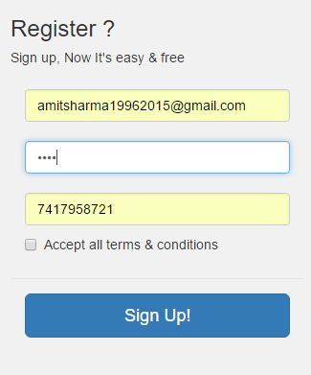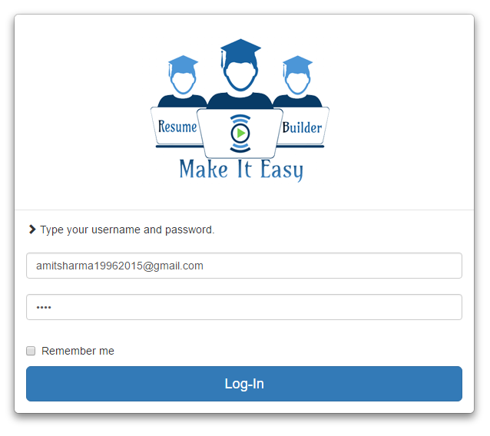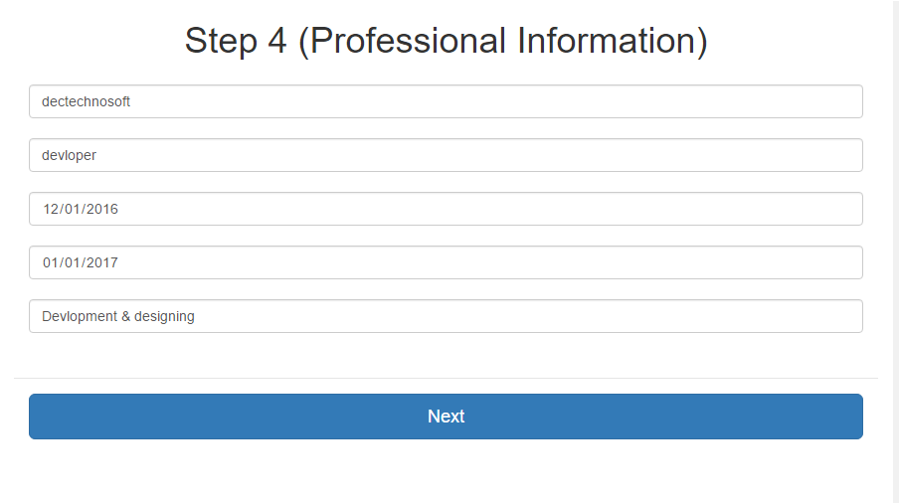

**Output**



**VII. System Security**

Computer security, also known as cyber security or IT security is the protection ofcomputer systems from the theft or damage to the hardware, software or the information on them, as well as from disruption or misdirection of the services they provide.

Security

* The system’s back-end servers shall only be accessible to authenticated management.
* It should give access to the registered administrator/user only.
* Abstraction is achieve by the help of server scripting language (php).
* Unauthorized access not available.
* Online system is secure from malicious software’s.

**VIII. Conclusions**

**Findings**

There are a number of factors in the client’s environment that may restrict the choices of a designer. Such factors include standards that must be followed, resource limits, operating environment, reliability and security requirements and policies that may have an impact on the design of the system. An SRS (Software Requirements Analysis and Specification) should identify and specify all such constraints.

* **Standard Compliance: -** This specifies the requirements for the standards the system must follow. The standards may include the report format and scheduling properties.
* **Hardware Limitations :-**The software may have to operate on some existing or predetermined hardware, thus imposing restrictions on the design. Hardware limitations can include the types of machines to be used, operating system available on the system, languages supported and limits on primary and secondary storage.
* **Reliability and Fault Tolerance: -** Fault tolerance requirements can place a major constraint on how the system is to be designed. Fault tolerance requirements often make the system more complex and expensive. Requirements about system behavior in the face of certain kinds of faults are specified. Recovery requirements are often an integral part here, detailing what the system should do I some failure occurs to ensure certain properties. Reliability requirements are very important for critical applications.
* **Security: -**Security requirements are particularly significant in defense systems and database systems. They place restrictions on the use of certain commands, control access to data, provide different kinds of access requirements for different people, require the use of passwords and cryptography techniques and maintain a log of activities in the system.

**SOFTWARE SYSTEM ATTRIBUTES**

**Reliability**

* The reliability of the overall project depends on the reliability of the separate components. The main pillar of reliability of the system is the backup of the database which is continuously maintained and updated to reflect the most recent changes. Thus the overall stability of the system depends on the stability of application and its underlying windows operating system.

**Availability**

* The system should be available at all times. In case of a of a hardware failure or database corruption, a replacement page will be shown. Also in case of a hardware failure or database corruption, backups of the database should be requested by the operator. Then the service will be restarted. It means 24 x 7 availability.

**Security**

* The system’s back-end servers shall only be accessible to authenticated management.
* It should give access to the registered administrator/user only.

**Maintainability**

* In case of a failure, a re-initialization of the project can be done.
* Also the software design is being done with modularity in mind so that maintainability can be done efficiently.

**Supportability**

* The code and supporting modules of the system will be well documented and easy to understand. User Documentation and Help System Requirements.

**Limitations**

* GUI is only in English.
* Login and password is used for identification of customer and there is no facility for guest.
* This system is working for single server.
* There is no maintainability of back up so availability will get affected.
* Limited to HTTP/HTTPS
* The details related to the product, customer, payment and service transaction provided manually.
* Administrator is created in the system already.
* Roles and tasks are predefined

**Future Scope**

* In future we will develop this software in the form of mobile app so that it could be used online as well offline mode.
* Companies can be added in this software so that they can directly fetch the resume of the candidate from one platform.
* Company’s information can be shared with job applicants.
* Mobile communication (message) can be added later on, for authentication and interview purposes.
* One advantage for employers to online resumes is the significant cost saving compared to traditional hiring methods.Another is that potential employers no longer have to sort through massive stacks of paper.
* A good resume is your passport to a better job.  
  Create your professional resume now and get more job interviews.
* Our project basically deals with generating a very effective resume that contain all the information of a student in a pre-defined format which is needed during placement session